**Selection of Consultants**

**Call for Expressions of Interest**

**PT Sarana Multi Infrastruktur (Persero)**

**French Development Agency**

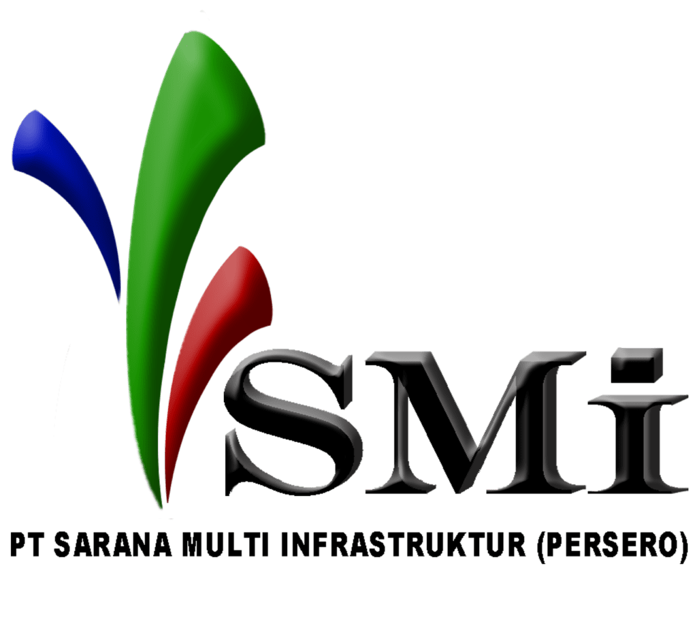



**May 2025**

***INDONESIA***

***Technical assistance programme for project preparation, communication and capacity-building activities in contribution to the SDG Indonesia One support to PT SMI in its mandate of financing infrastructure projects with Climate or SDG related benefits in Indonesia***

***Project ID: CID 1090***

**CONSULTING SERVICES**

**Expressions of interest**

In order to promote and support the financing of SDG projects in Indonesia, the *Agence Française de Développement* (“**AFD**”), with the financial support of the European Union (the “**EU**”), concluded in 2020 a project in partnership with the Indonesian Public Development Bank *PT Sarana Multi Infrastruktur (Persero)* or “**PT SMI”**.

As a second partnership between AFD and PT SMI, this new project has brought their relationship to another level, by helping PT SMI’s ongoing transition from a public bank financing infrastructure projects to a new model of financial institution as a full-fledged development bank contributing to Indonesia's sustainable development goals (SDGs).

With a view to support the implementation of PT SMI’s programme to promote and finance SDG projects in the country, the project was indeed aimed to address Indonesia's infrastructure gap by supporting sustainable development projects through financial support, technical assistance, and a de-risking mechanism/investment grant made available to the clients of PT SMI. As such, the following resources were provided to PT SMI:

- (Component 1) a 150M USD non-sovereign credit-facility from AFD;

- (Component 2) a 500 000 EUR grant from AFD to support PT SMI in the disbursement, follow-up/ monitoring and justification of the use of the funds of the credit-facility; and

- (Component 3) a 5M EUR **grant mobilised by AFD from the EU** under the EU Asia Investment Facility (“EU AIF”) Programme **in order to make it available to PT SMI for** the financing of investment premiums (for up to 2M EUR – Component 3.1) and of a **technical assistance** for project preparation, communication and capacity-building activities, as well as evaluation/audit activities (for up to 3M EUR - Component 3.2).

As of today, AFD’s credit-facility to PT SMI has been fully used and allowed for the financing of investments with climate or social co-benefits (e.g. in health as an answer to the COVID crisis situation).[1] For its part, apart from a few activities that have been carried out in support to PT SMI, t**he technical assistance programme component of the project (Component 3.2) remains to be implemented.**

To this end, AFD is applying for the extension till end of May 2027 of the period of validity of the funds made available to the project by the EU. Once confirmation of the extension of the funds is received, PT SMI intends to use part of the amount of Component 3.2 thereof to make payments under a **Technical assistance programme for project preparation, communication and capacity-building activities in contribution to the SDG Indonesia One support to PT SMI in its mandate of financing infrastructure projects with Climate or SDG related benefits in Indonesia,** with a maximum budget of one million and nine hundred thousand euros (EUR 1.9 million), inclusive of all taxes.

The Services of the consultant shall consist of:

*1. Project preparation activities,* in the form of studies carried out on renewable energy projects or investments considered for financing by PT SMI such as hospital

2. *Capacity-building activities* to PT SMI (and possibly its clients), on risk-management, climate change and social issues, including gender

*3. Verifying the additionality of the funds from the investment grant* (Component 3.1) when used by PT SMI to support the financing of its clients’ investments.

*4. Communication activities,* contributing to the visibility of the programme and its impacts. These activities shall include the production of video materials, and other diverse activities such as the organisation of events and workshops aimed to promote PT SMI’s activities and mission and raise-awareness on climate change and development matters.

PT SMIinvites Candidates to express their interest in providing the Services described above.

This Call for Expressions of Interest is addressed to:

x

|  |  |
| --- | --- |
| * Design offices, Consulting firms | * Individual consultants |
|  | x |
| * NGOs | * NGO(s) and/or consulting firm(s) in a consortium (joint-venture) |

Eligibility criteria for AFD financing are specified in Article 1.3 of the " Procurement Guidelines for AFD‑Financed Contracts in Foreign Countries ", available online on the AFD website: http://www.afd.fr.

Candidates may submit only one application in their own name or as a consortium / joint-venture. If a Candidate (including a member of a consortium / joint-venture) submits or participates in several applications, these will be eliminated. However, the same Subcontractor may participate in several applications.

If the Respondent is a consortium / joint-venture, the Expression of Interest must include:

* a copy of the consortium / joint-venture agreement signed by all its members,

or

* a letter of intent to form a consortium / joint-venture, signed by all members and accompanied by a copy of the proposed consortium / joint-venture agreement.

In the absence of this document, other members will be considered as subcontractors.

Subcontractors' references and qualifications are not taken into account in the evaluation of applications.

Interested Candidates must provide information demonstrating that they are qualified and experienced to perform the present Services. To this end, they must provide references for recent and similar services.

The similarity of references will be analyzed according to :

* The contract size, estimated EUR 1.9 million;
* The nature of the Services: (i) carrying out project prepraration studies for renewable energy and hospital, including feasibility studies, Environmental and Social (E&S) impact studies, climate change vulnerabiliy assessments of projects, technical or financial complementary analysis of complex investments, or legal due diligence on the projects; (ii) delivering capacity-building services, including running trainings and development training materials, on-the job capacity building experience, etc.; (iii) implementing communication activities, both for event organisation and for the development of suppports and communication materials.
* Field and technical expertise: Climate change, Renewable Energy or Hospital Finance, E&S, Engineering, Environmental and Social issues, Legal, Gender, Communication, Project assessment and analysis, Training and pedagogy.
* The geographical context relevance, i.e. working experience in the Client’s country (Indonesia) or region (Southeast Asia).

The Customer will also examine the relevance of the Expressions of Interest with regard to the following criteria:

* In-house skills and availability for technical support to in-country experts;
* Local correspondents/partners;
* Candidate's quality assurance procedures and certifications - specify purpose or title of certification: e.g. ISO 9001 or environmental and social certification.

PT SMIwill draw up a shortlist of a maximum of six (6) Candidates, pre-selected on the basis of the applications received, to whom it will send the Request for Proposals for the performance of the required Services.

Expressions of Interest should be **submitted to the postal or email address below, by *June 30,*  2025*.***

Procurement Committee PT Sarana Multi Infrastruktur (Persero)

Mailroom PT Sarana Multi Infrastruktur (Persero)

Sahid Sudirman Center, Lantai 47, Jl. Jend. Sudirman No.86, RT.10/RW.11,

Karet Tengsin, Kecamatan Tanah Abang,

Kota Jakarta Pusat, Daerah Khusus Ibukota Jakarta 10220, Indonesia

Email address: [pengadaan@ptsmi.co.id](mailto:pengadaan@ptsmi.co.id)

Interested Candidates may obtain further information at the email address above, during office hours: from Monday to Friday, 8.30 am to 5.30 pm (GMT+7).

Appendix to the Expression of Interest   
(To be provided signed with the application, without modification of the text)

Statement of integrity, eligibility and environmental and social responsibility

Title of signed offer/proposal/Contract [2] (the "**Contract**")

A : (the "**Project Owner**")

1. We acknowledge and accept that the Agence Française de Développement (the "**AFD**") only finances the Employer's projects on its own terms, which are determined by the Financing Agreement that links it directly or indirectly to the Employer. The Employer retains exclusive responsibility for the preparation and implementation of the contract award process and its execution. Consequently, there can be no legal relationship between AFD and our company, our consortium or our subcontractors. Depending on whether the Contract is for works, supplies, equipment, intellectual services (consultants) or other services, the Client may also be referred to as the Customer, Contractor or Purchaser.
2. We certify that neither we, nor anyone acting on our behalf[3] , nor any member of our group, nor any of our subcontractors, are in one of the following cases:

2.1 Be in a state of or have been the subject of bankruptcy, liquidation, judicial settlement, safeguard, cessation of activity proceedings, or be in any similar situation resulting from proceedings of the same nature;

2.2 Have been the subject, for less than five years, of a definitive administrative sanction, a definitive conviction handed down by a competent authority, or any other resolution outside of legal proceedings[4] having, in particular, the effect of extinguishing public action, either (i) in the country in which we are established, (ii) in the country where the Contract is carried out, (iii) in connection with the award or performance of a contract financed by AFD, (iv) pronounced by an institution of the European Union or (v) pronounced by a competent authority in France, for :

1. Prohibited practices, as defined in article 6.1 below, or for any offence committed in connection with the award or performance of a Contract (in the event of such a sanction, conviction, or resolution out of court, we have the option of attaching to this Integrity Statement additional information, such as a compliance program, to justify that we (or the person acting on our behalf, the member of our consortium, or our subcontractor) consider that the sanction, conviction or resolution is not relevant in the context of the Contract, as the case may be);
2. participation in a criminal organization, terrorist offences or offences related to terrorist activities, child labor, or other offences related to human trafficking;
3. having created an entity in a different jurisdiction with the intention of evading tax, social security or any other legal obligations applicable in the territory where its registered office, central administration or principal place of business is located or (ii) for being an entity created with the intention of evading such obligations;

2.3 Have had a contract terminated to its sole detriment within the last five years due to a serious or persistent breach of its contractual obligations during the performance of a contract, provided that this termination has not been the subject of a dispute on its part which is being processed or which has given rise to a court decision overturning the termination to its sole detriment;

2.4 Be the subject of an ineligibility measure taken by one of the multilateral development banks that are signatories to the mutual recognition agreement of April 9, 2010[5] (in the event of such an ineligibility measure, we may attach to this Integrity Statement additional information that would make it possible to consider that this ineligibility measure is not relevant in the context of the Market), if applicable;

2.5 Not having fulfilled our obligations relating to the payment of taxes or social security contributions in accordance with the legal provisions of our country of establishment, or those of the country of the project owner;

2.6 Filing false documents or making false declaration(s) in providing the information required by the Employer as part of the present Contract award process.

1. We certify that neither we, nor anyone acting on our behalf2 , nor any member of our group, nor any of our subcontractors, nor any of our direct or indirect shareholders, nor any of our subsidiaries, acting with our knowledge or consent :
   1. is directly or indirectly targeted, controlled by a targeted person or entity, or acts in the name of or on behalf of a person or entity targeted by individual sanctions measures adopted by the United Nations, the European Union and/or France;
   2. is directly or indirectly targeted, controlled by a targeted person or entity, or acts in the name of or on behalf of a person or entity targeted by sectoral sanctions measures adopted by the United Nations, the European Union and/or France;
   3. is ineligible to carry out the project due to any other international sanctions imposed by the United Nations, the European Union or France.
2. We certify that neither we, nor anyone acting on our behalf2 , nor any member of our consortium, nor any of our subcontractors, are (or have been *(in the case of refinancing a contract already awarded)*) in one of the following conflict of interest situations:

4.1 Be a shareholder controlling the project owner or a subsidiary controlled by the project owner, unless the resulting conflict has been brought to the AFD's attention and resolved to its satisfaction;

4.2 Have a business or family relationship with a member of the project owner's staff involved in the contract award process or the supervision of the resulting contract, unless the resulting conflict has been brought to the attention of AFD and resolved to its satisfaction;

4.3 Control or be controlled by another candidate, bidder or consultant, be under the control of the same company as another candidate, bidder or consultant, receive subsidies from or award subsidies to another candidate, bidder or consultant directly or indirectly, have the same legal representative as another candidate, bidder or consultant, bidder or consultant, maintain direct or indirect contacts with another candidate, bidder or consultant enabling us (i) to have given, and/or to give access to, information contained in our respective candidatures, bids or proposals of such a nature as to distort competition, (ii) to influence them, or (iii) to influence the project owner's decisions;

4.4 Be engaged for an intellectual service mission which, by its nature, is or could be incompatible with the mission envisaged on behalf of the project owner;

4.5 To have prepared itself, to be or to have been associated with a natural or legal person who has prepared specifications, terms of reference and other documents which have been used within the framework of the procedure for the award of this Contract, and which contain provisions of such a nature as to favour an application, offer or proposal;

4.6 Having access to or having had access to, having prepared oneself, being or having been associated with a natural or legal person who has access to, had access to, or prepared specifications, plans, calculations, studies and other documents which have not been communicated to all candidates, tenderers or consultants in the context of the present contract award, and which thus confer an undue competitive advantage;

4.7 In the case of a procedure for the award of a Contract for works, equipment or supplies, to be recruited, or to be required to be recruited (or that one of the companies with which we are affiliated be recruited, or to be required to be recruited), to carry out the supervision or control of services under the Contract.

1. If we are a public institution or company, to take part in a competitive bidding procedure, we certify that we are legally and financially autonomous, and that we are managed according to the rules of commercial law.
2. In connection with the award and performance of the Contract :

6.1 Neither we, nor anyone acting on our behalf2 , nor any of the members of our consortium, nor any of our subcontractors, have committed or will commit any Prohibited Practice as defined in the document entitled "AFD Group's General Policy on Preventing and Combating Prohibited Practices", available on the AFD website .[6]

6.2 Neither we, nor anyone acting on our behalf2 , nor any member of our consortium, nor any of our subcontractors, will acquire or supply (have acquired or supplied *(in the case of refinancing of a contract already awarded)*) any equipment or intervene (have intervened *(in the case of refinancing of a contract already awarded)*) in sectors under embargo by the United Nations, the European Union or France.

1. We undertake to, and we undertake that anyone acting on our behalf2 , any member of our group, any subcontractor undertakes to :

7.1 to comply with environmental standards recognized by the international community, including international conventions for the protection of the environment, and in particular to take all reasonable measures to avoid or limit the negative effects on vegetation, biodiversity, soil, groundwater and surface water, and on people and property, resulting from pollution, noise, vibrations, traffic and other effects resulting from our activities, in accordance with the laws and regulations applicable in the country where the Contract is carried out.

7.2 to implement environmental and social risk mitigation measures where indicated in the environmental and social management plan provided by the project owner, and to ensure that emissions, surface discharges and effluents produced by our activities comply with the limits, specifications or requirements applicable to the Contract.

7.3 respect workers' rights with regard to wages, working hours, rest and vacation, overtime, minimum age, regular payments, compensation and benefits in accordance with internationally recognized standards, including the fundamental conventions of the International Labor Organization (ILO), consistent with the laws and regulations applicable in the country where the Contract is performed; indicate these elements in a document attached to our employees' employment contracts and available to the project owner; and respect and facilitate workers' rights to organize and set up a complaints management mechanism for direct or indirect workers.

7.4 implement practices of non-discrimination and equal opportunity, and ensure the prohibition of child labor and forced labor.

7.5 maintain a file for each member of the local staff recording the hours worked by each person, the type of work, the wages paid and the training attended, and that these files are available at all times so that they can be examined by the Employer and authorized government representatives, in compliance with the laws and regulations applicable to the protection of personal data in the country where the Contract is carried out.

1. We, anyone acting on our behalf2 , the members of our consortium, our subcontractors, our direct or indirect shareholders, and our subsidiaries authorize AFD to conduct investigations, and in particular to examine the documents and accounting records relating to the award and performance of the Contract, including, but not limited to, our internal processes and procedures relating to compliance with international sanctions imposed by the United Nations, the European Union and/or France, and to have them verified by auditors appointed by AFD.
2. We declare that we have paid, or will pay, commissions, benefits, fees, gratuities or expenses in connection with the procurement process or the performance of the Contract to the following third party(ies) (such as an intermediary/agent)(*) :

|  |  |  |  |
| --- | --- | --- | --- |
| **Beneficiary name** | **Contact** | **Pattern** | **Amount (Specify currency)** |
| _________________ | _________________ | _________________ | ________________ |
| _________________ | _________________ | _________________ | ________________ |
| _________________ | _________________ | _________________ | ________________ |

(*): If no amount has been paid or is to be paid, indicate "None".

1. We undertake to inform the project owner without delay, who will inform AFD, of any change in the situation with regard to the above points, including in the event of any sanctions or embargoes adopted by the United Nations, the European Union and/or France following our signature of this Declaration.

Name: As :

Duly authorized to sign for and on behalf of[7] :

Signature :

As of :

1. The eligibility criteria set for the credit-facility in the agreement signed between AFD and PT SMI allowed for the financing of social investments within the limit of 30% maximum of the total amount of the credit-facility.
2. In the case of a signed contract to be refinanced.
3. Executives (including any member of the administrative, management or supervisory bodies or who has powers of representation, decision-making or control), employees or agents (whether declared or not).
4. These include the Convention Judiciaire d'Intérêt Public (CJIP), the decision following a Comparution sur Reconnaissance Préalable de Culpabilité (CRPC), the negotiated settlement agreement or any other similar form of transaction putting an end to prosecution.
5. World Bank, Inter-American Development Bank, African Development Bank, Asian Development Bank and European Bank for Reconstruction and Development.
6. For your information, this policy can be accessed via the following link: https://www.afd.fr/fr/lutte-contre-la-corruption
7. In the case of a joint venture, enter the name of the joint venture. The person signing the bid, proposal or application on behalf of the bidder, consultant or candidate shall attach to it the power of attorney entrusted to him by the said bidder, consultant or candidate.